Fiverr Custom Offer App

**THE MAIN POINT OF THE APP IS TO SEND OFFERS IN THE BUYER REQUEST PART.**

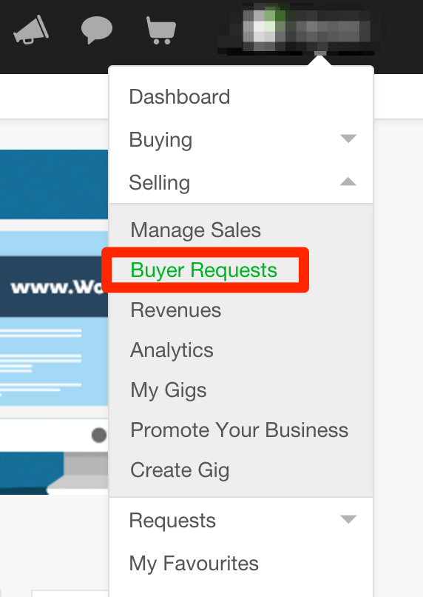

**HOW DOES IT WORK?**

IN THE APP (Fiverr Cutom Offer App) will have a section to put the category of the offer you would like to send and this part must match with the part of the category on Fiverr.com

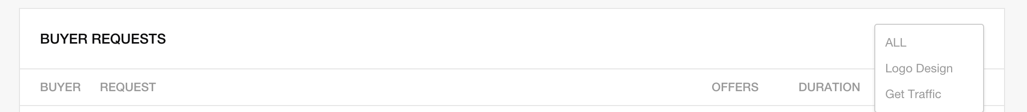

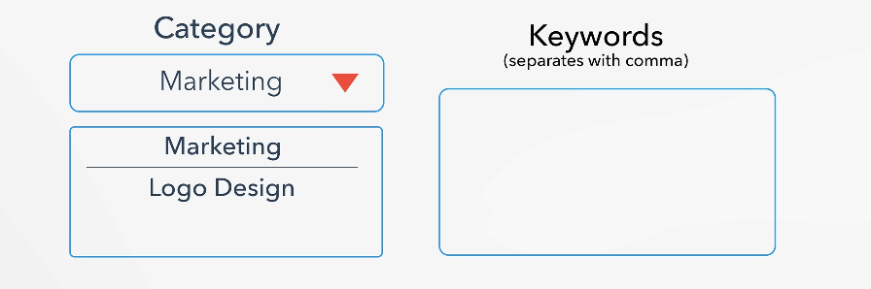

In the keyword part, you can type the keyword that you want to search offer, for example, if I type: website, seo, clicks, then the software must search for people have website or seo or clicks in their request.

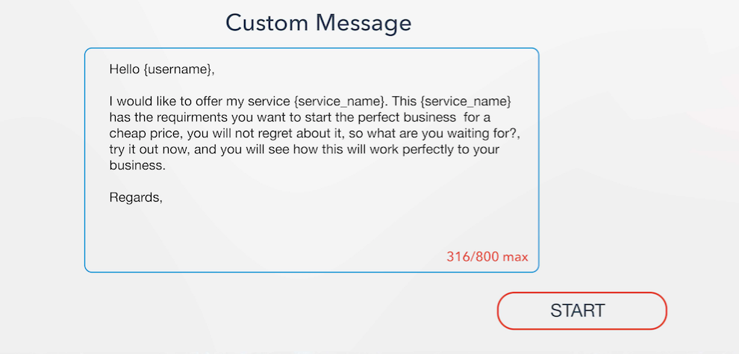

In the Custom message type, you can type the message you want to send to them.

Note: I would also like to have the variables, for example, if I type {username}, then the software must search the username of the person I am sending the offer and replace it in the {username} part