Note: Each instance is run via unique proxy (supplied by us) so that TD cannot tell we are using multiple instances, etc.)

Step #1: Log In to Tweetdeck (Info supplied by us to software)
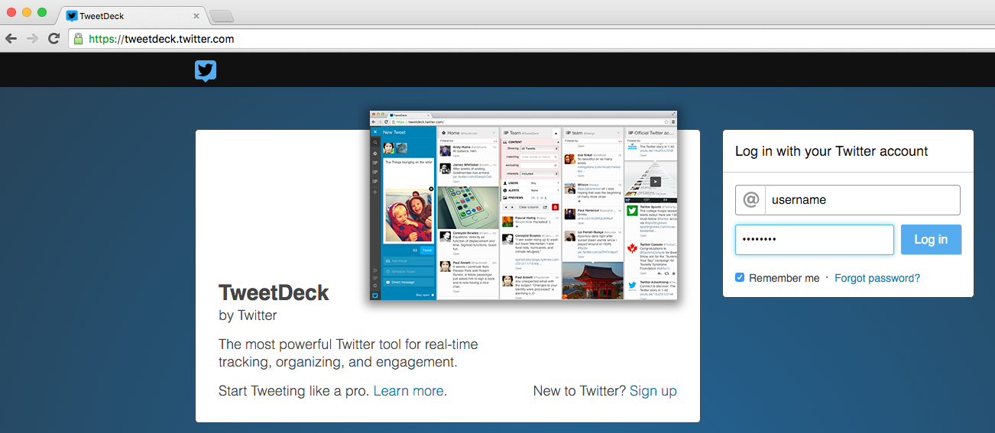

Step #2: Open side search bar.
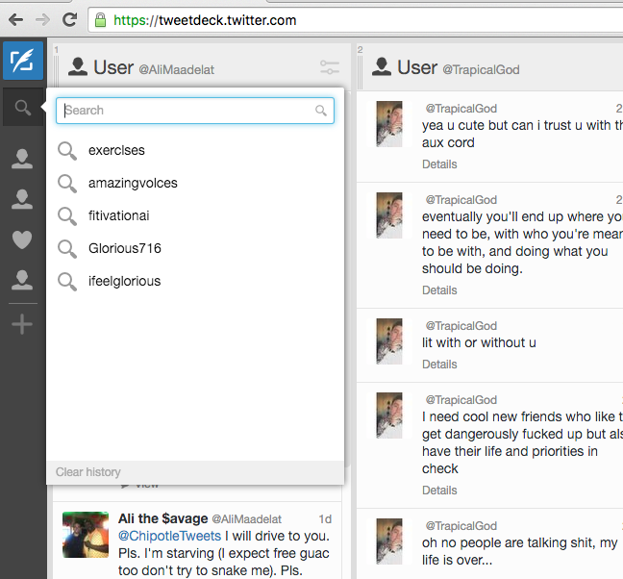

Step #3: Type username into search (supplied by us)

Step #4: Once account loads, select “likes”

Step #5: Select “retweet” on post based on selected variables.
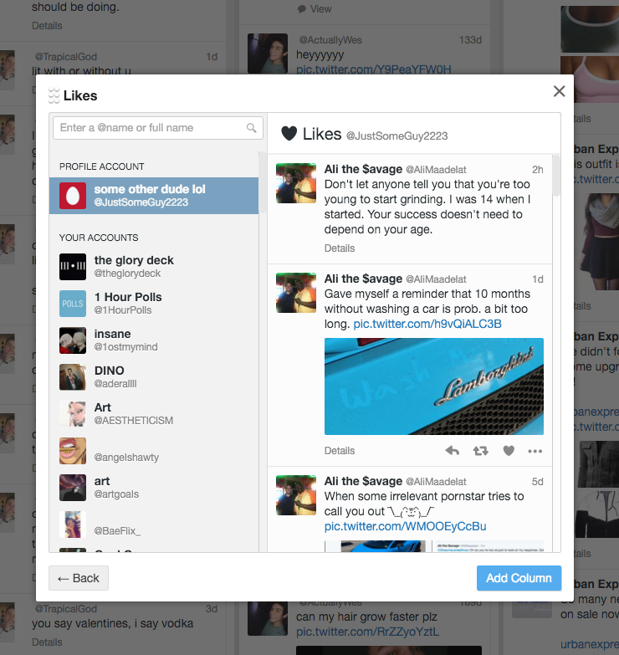

Step #6: Select accounts based on variables (mainly, do not select accounts that have been “blacklisted”)
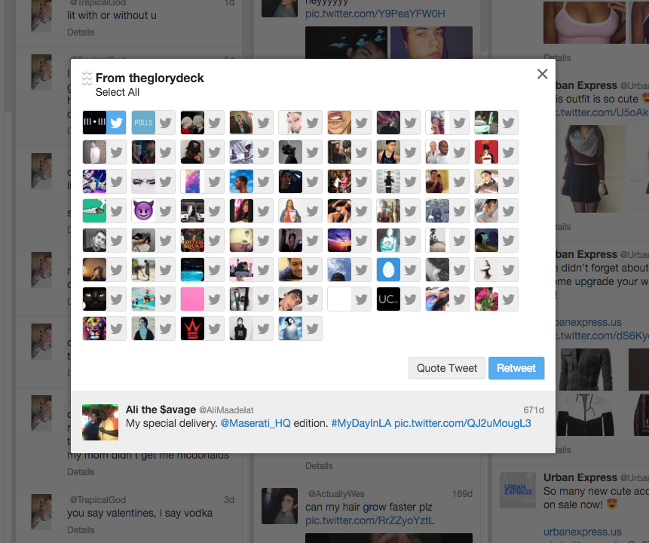

(Example, in the image below, first account has been “blacklisted” so it selects all other accounts, then hits retweet at bottom right.)
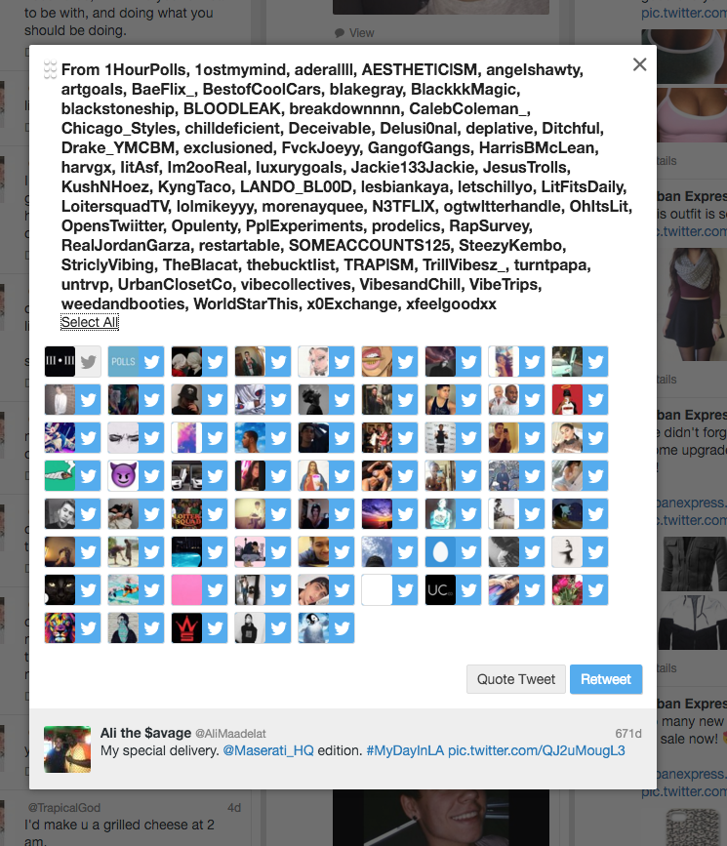

Step #7: Once everything has worked, save time of tweet, and URL of tweet to log file.

Step #7: Wait for previously entered amount of time we have told it to wait between retweets, then continue from Step #2-7. (If tweetdeck has been logged out, automatically log in again.)

It would be nice for data entry for application to work like this:

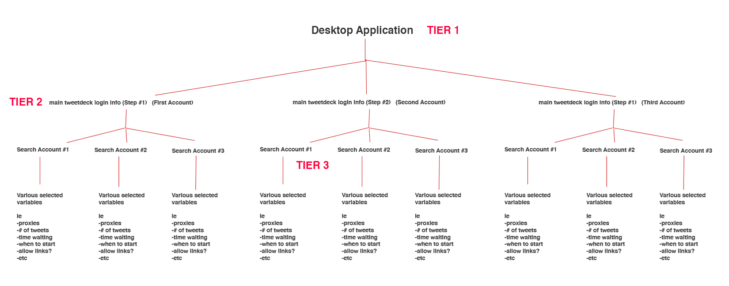

in this way, we can change the step #1 info (login for tweedeck) one time and it will smoothly make all running search account queries log in to the new info (for example, if we change password), but also allows us to customize the specifications (wait time, proxy, etc.) for all different accounts being retweeted.

Again, we would want to use multuope

List of variables required:

TIER 1 Variables:
- Proxy list
- Proxy cycle time (ie, every 6 hours, change proxy)

Note: Proxy list + variables are uploaded to Tier 1, main application, however, EACH Search account requires a different proxy. As long as we chooe a RANDOM proxy for each search account, the chance of same proxy being used for different accounts is very rare and not a problem.

Tier 2 Variables:
- Tweetdeck Username
- Tweetdeck Password
- What accounts should NOT be selected on “select account” page after selecting tweet.
- Status light (green/red) and error note in case of problem.

Tier 3 Variables:
- Account username to search
- Time to wait (in seconds) between retweets
- -In what order to select tweets to retweet (for example: random, newest to oldest, oldest to newest)
- How many tweets from most recent to count (for example, all tweets that are liked or for example 20 would be “most recent 20 tweets that are liked)
- Allow tweet with URL? Yes/No (if yes, then we say how many tweet with URL per day are allowed. If no, then the application will skip tweets that have URL in it, make sense? If yes and, for example, 1 URL tweet per day, after it has hit 1 url tweet, it will skip any URL tweet until next day starts)
- Start time of first retweet (for example, 00 minutes of hour, 05 minutes of hour, 07 minutes of hour etc.)
- Status light (green/red) and error note in case of problem.

Note, also every time a tweet is retweeted, as I said it should save the data in TXT or CSV file (time, what is url of tweet, etc.)

Once it has gone through entire list of tweets, it should then restart again.

If tweetdeck logs out for any reason, it should relogin again (normally this is at Tier 2 level)

